Assignment 3: High-lift system analysis in 2D flow
Academic year: 2025-2026
Full Name: | Dennis Heintz
Student Number: | 6219675
Date: | 28.01.2026

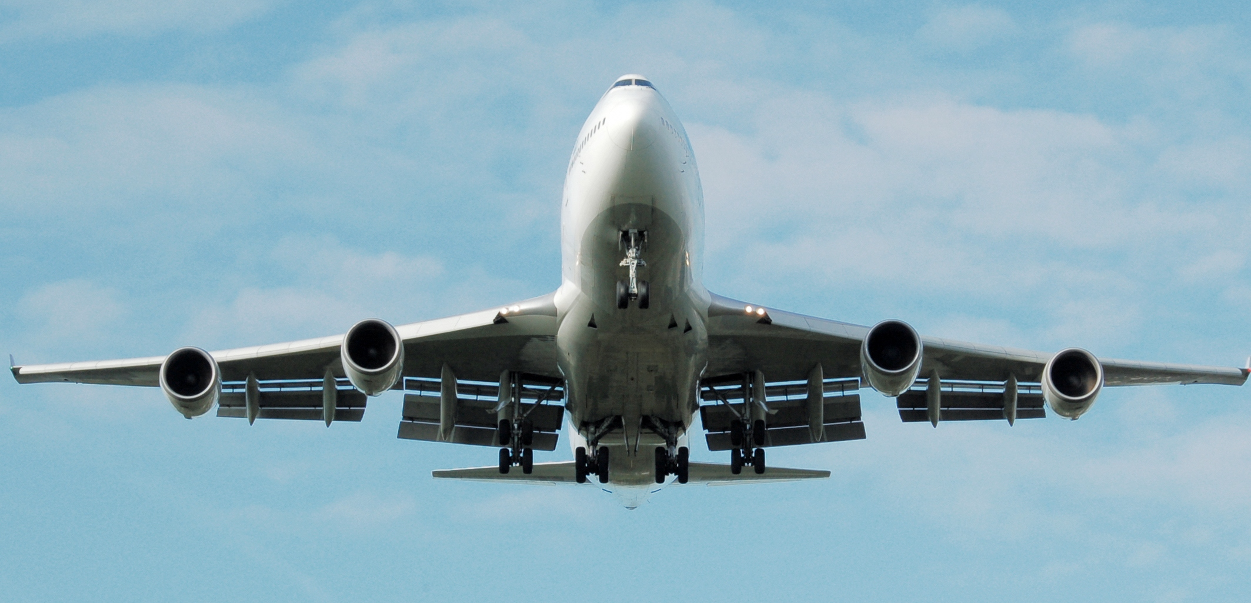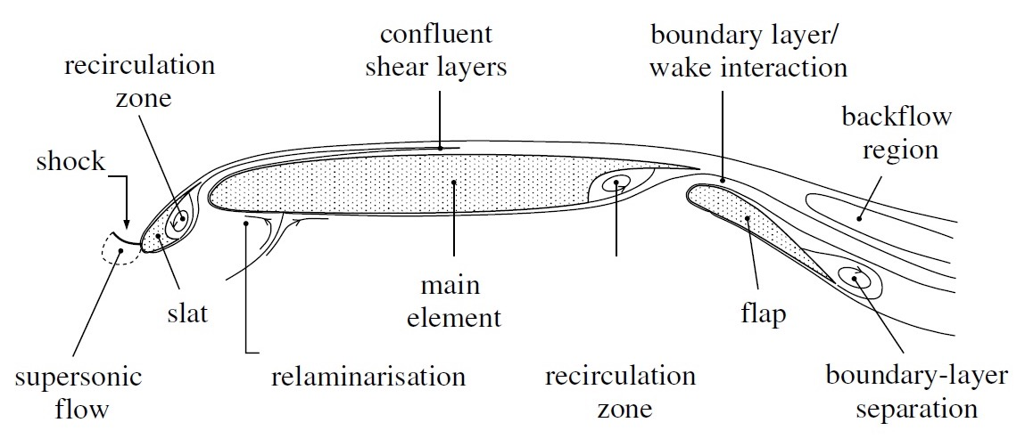

Requirements
- Personal / group task: personal
- Handwritten drawings must contain a visible signature and date to its side
- Be as complete as necessary, as succinct as possible

Introductionover
Multi-element airfoils play a key role in attaining high performance in take-off and landing conditions of aircraft. The design of systems with leading edge and trailing edge devices is complicated due to the strong interaction effects between the different elements (see ref. 1 and ref. 2 in Handout # 3).
As is evinced by results from literature, several factors make the design of a high lift system very difficult:
- The limited accuracy with which flow separation can be predicted with modern CFD codes
- The possible occurrence of wake bursting
- The effects of compressibility on the flow field over the different elements
- Potential bursting of laminar separation bubbles and associated detrimental hysteresis effects
The task of defining an acceptable high lift system becomes a non- trivial and laborious task. In this assignment, we will only concentrate on a low fidelity analysis of an airfoil equipped with a trailing edge flap and estimate the basic effects.

Preparation
Task 2 of this assignment requires you to simulate the flow over a multi-element airfoil. You are free to choose your own method. A suggestion for an easy access tool is “JavaFoil”, based on an applet that is available on the internet. Please ensure to force turbulent flow over the entire airfoil so comparisons can be drawn regardless of transition location.
After having defined your means of simulation, you are asked to find a relevant 2D-case in open literature of an airfoil main element with a trailing-edge flap. A very good reference case is the so-called NLR 7301 airfoil with flap [4]. Alternatively, you can also select an airfoil of your choosing (for example the one used during Assignment 2) and add two of them together to create a multi-element airfoil. You are free to select an alternative model.
Along with the main element + flap geometry, reconstruct a “like-wise” single element airfoil that consists of the main element only, representing the retracted condition.
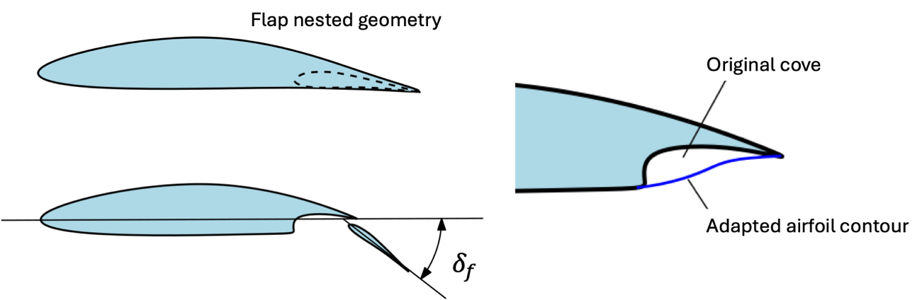
Figure 1 - Geometry of the flap nested case (left) and adaptation of the cove area to prevent computational problems (right)

References
1. A.M.O. Smith. "High-Lift Aerodynamics", Journal of Aircraft, Vol. 12, No. 6 (1975), pp. 501-530.
2. C.P. van Dam, “The aerodynamic design of multi-element high-lift systems for transport airplanes”, Progress in Aerospace Sciences 38, 101–144, 2002
3. M. Hepperle, Javafoil, http://www.mh-aerotools.de/airfoils/javafoil.htm
4. NLR 7703 data: https://www.grc.nasa.gov/www/wind/valid/nlrflap/nlrflap01/nlrflap01.html

Task 1 – Theoretical background
To get some further insight in the interaction effects between elements in a high lift system perform the following tasks:
- Difference in working principle between a leading-edge slat and a trailing-edge flap.
  - In the box below, succinctly explain the main differences in the working principle between a leading-edge slat and a trailing-edge flap.
The main purpose of the slat is to increase the maximum angle of attack of the airfoil. This is achieved by the trailing edge flow of the slat running counter to the flow over the airfoil. As a result, the suction peak on the airfoil is reduced, and consequently, the adverse pressure gradient too, thereby delaying flow separation.
A flap’s main purpose is to increase the maximum lift coefficient of the airfoil. A flap achieves this by increasing the circulation around the airfoil. The circulation is modified by inducing higher flow velocities and an effective higher angle of attack at the trailing edge of the airfoil. In a non-lifting flow, this would result in a shift of the rear stagnation point towards the front of the airfoil. In a lifting flow, therefore, an increase in circulation is required to ensure the flow exits the airfoil at the trailing edge to satisfy the Kutta condition.

  - Insert a drawing showing how the lift coefficient polar, $C_{l}$ vs. $α$ , of an airfoil is modified by the inclusion of a leading-edge slat and a trailing-edge flap.
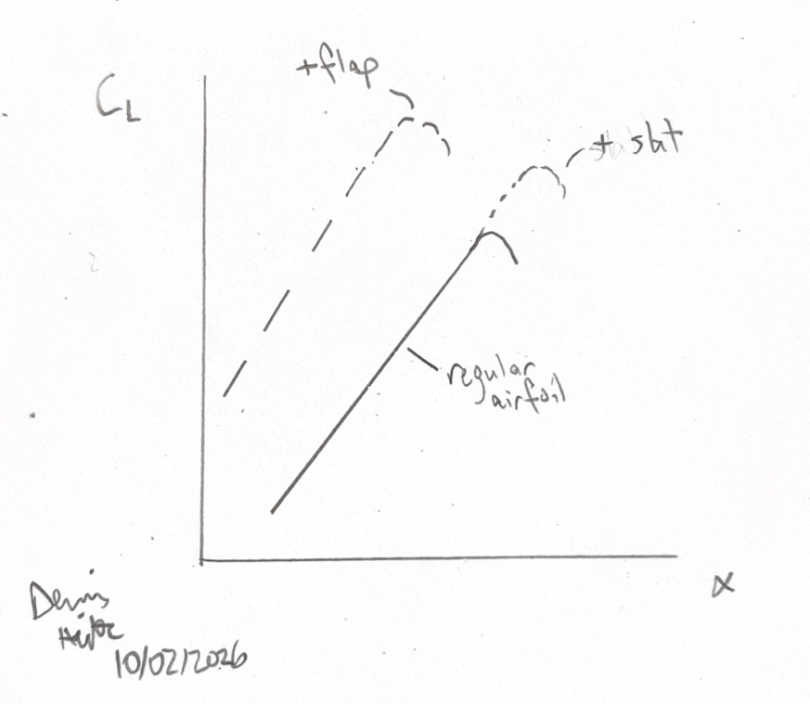

- Read the paper from reference [1] (also available from a handout in BrightSpace) and describe in your own words the following effects that determine the behaviour of a high lift system. In the second box, please add your own clear hand-drawn sketches (no copies!) that support the discussion on the top row and a succinct description on the bottom one. Do not forget to add signature and date.

  - Slat Effect
At the trailing edge of the upstream element the induced velocities run opposite to the velocities induced at the leading edge of the downstream element. This reduces the peak velocities flowing over the downstream element and as a result lower the suction peak. This leads to a smaller adverse pressure gradient in the boundary layer which delays the onset of flow separation.
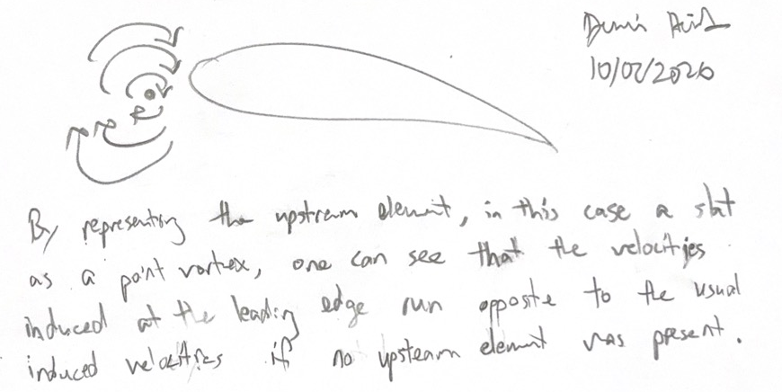

  - Circulation Effect
A downstream element increases the velocities and apparent angle of attack of the upstream element. As previously mentioned, an increase in circulation on the upstream element is then induced as to satisfy the Kutta condition.
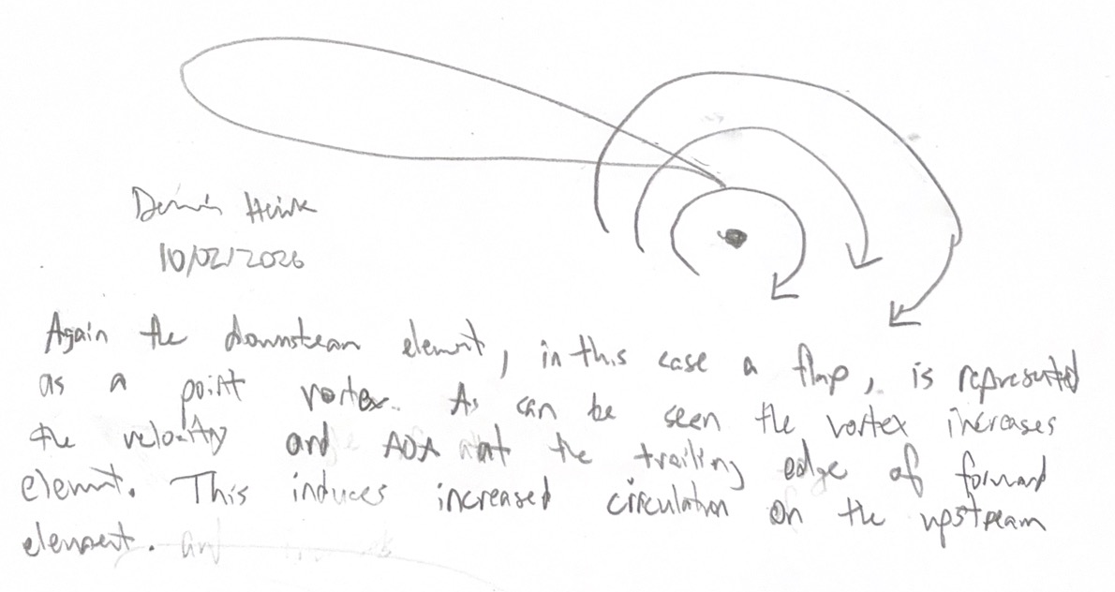

  - Dumping Effect
The dumping refers to the greater than freestream velocities at the trailing edge of an upstream element. This effect reduces the adverse pressure gradient the boundary layer faces while in contact with the surface and helps with keeping flow attached for longer. Furthermore, this effect allows elements to support higher loads.
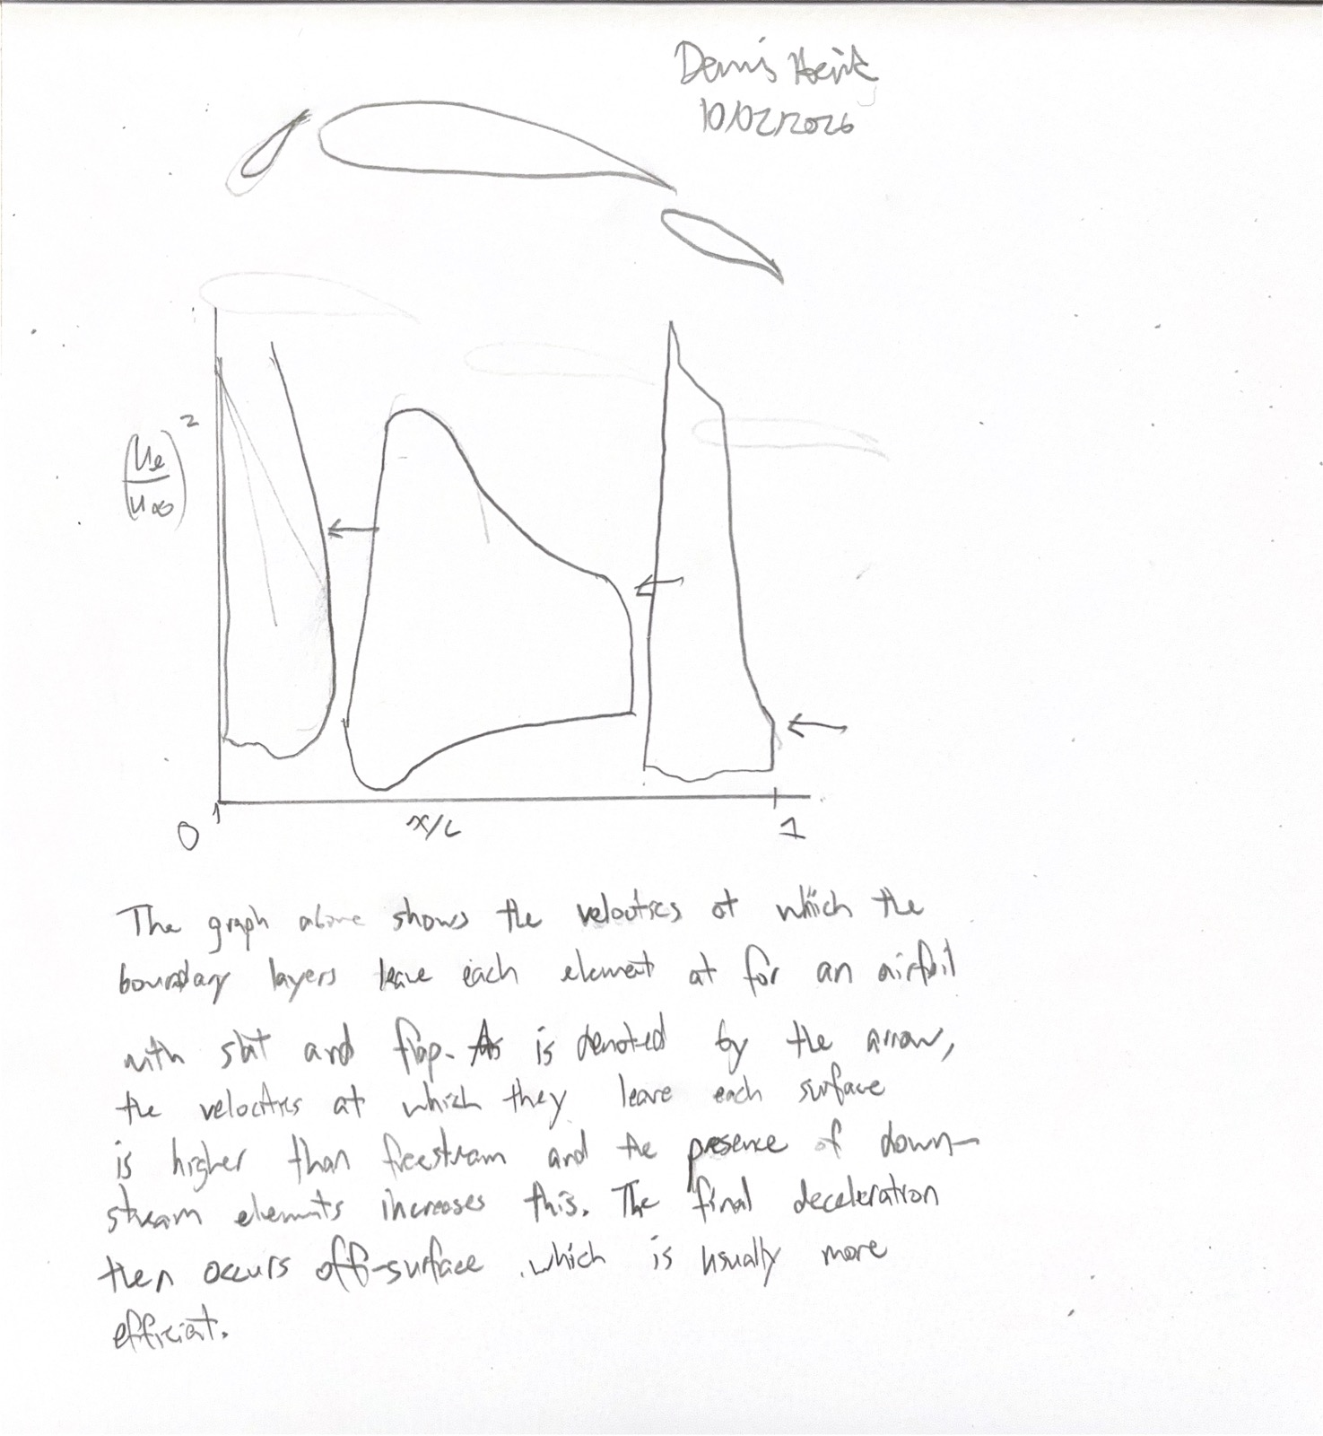
The figure above shows the ratio of the flow velocity to the freestream velocity. For a typical airfoil, this ratio is usually below 1 at the trailing edge. In a multi element system, such as the one shown, the dumping velocity ratio is 2.28, 2.0, and 0.67 respectively. This increased velocity decreases the pressure recovery demand on the boundary layer and helps with keeping the flow attached and increases the loading capability.

  - Off-the-surface Pressure Recovery
Related to the dumping effect, the off-the-surface pressure recovery effect refers to the pressure rise the boundary layer has to overcome after leaving the trailing edge. As the flow is at a higher velocity than freestream, the lower pressure flow must decelerate. Due to the dumping effect, this occurs off the surface which is generally more efficient compared to the pressure recovery happening while in contact with the surface.
The same figure as for the dumping effect can be used to show the off-the-surface pressure recovery as it shows the flow exiting the elements at appreciably higher velocities than freestream which implies that the pressure rise must occur off the surface.

  - Fresh Boundary Layer Effect
A fresh boundary layer forms on new elements which essentially resets the boundary layer thickness. As a boundary layer develops across an element’s surface, it grows as momentum is diffused away from the surface. This makes the boundary layer more prone to separation when experiencing an adverse pressure gradient, and increases pressure drag. A new element allows for a new boundary layer to form that starts out thinner and can sustain a larger adverse pressure gradient, keeping flow attached for longer.
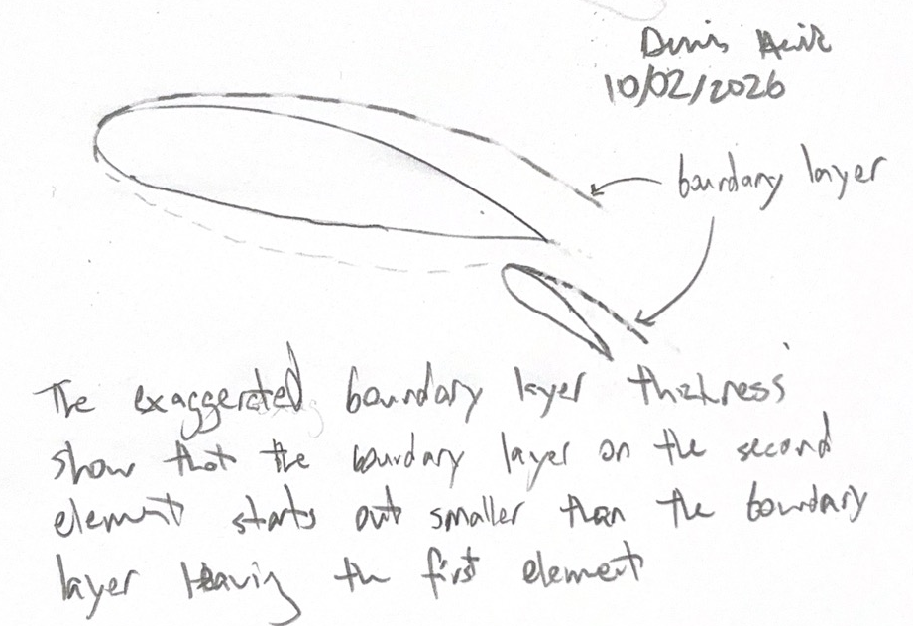

Task 2 – Numerical analysis
Find a relevant 2D-case in open literature of a main element with a trailing-edge flap. A very good reference case is the so-called NLR 7301 airfoil with flap [4], but you are free to select an alternative model. Along with the main element + flap geometry, use a “like-wise” single element airfoil that consists of the main element only (see fig. 1).
- Provide bibliographical details of all references used and the airfoils chosen.
Spooner, Stanley H, and Ernst F Mollenberg. NACA, Positioning Investigation of Single Slotted Flaps on a 47.7 Degrees Sweptback Wing at Reynolds Numbers of 4.0e6 and 6.0e6, https://ntrs.nasa.gov/citations/19930090395. Accessed 29 Jan. 2026.
For the extended case, the NACA 64-210 airfoil is used for both the main element and the flap. For the retracted case, the airfoil consists of the NACA 64-210 airfoil with a $5°$ flap deflection set in Javafoil at the x/c=0.75 position.

- Add a figure of the high-lift airfoil and your single element airfoil
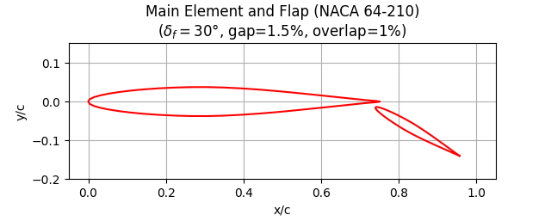

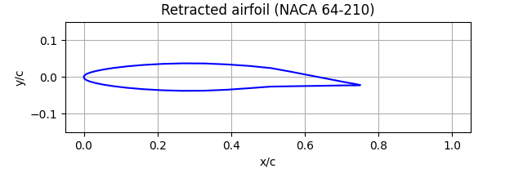

  - Select a realistic flap deployment angle, $δ_{f}$, and add a plot of the lift polar curve ($C_{l}$ vs. $α$) for the retracted flap case versus the one with extended flap. Add the Reynolds number used in the calculations.
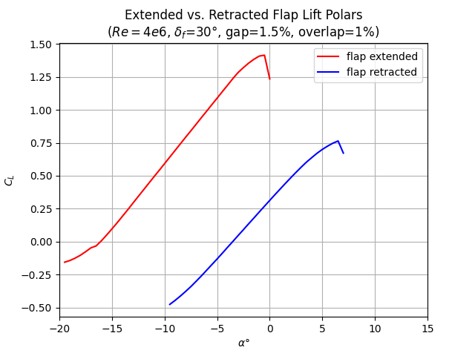

  - Comment if the differences match the expected effect of the flap. If not, explain what might be happening?
As expected, the lift polar is shifted upwards and to the left when the flap is extended. This is a result of the increased circulation over the main airfoil which increases the lift. However, the increase also creates a larger suction peak on the main airfoil which leads to larger adverse pressure gradients and causes earlier flow separation. This results in stall at a lower angle of attack which clearly present as seen by the leftward shift of the lift polar.

  - Add two plots of the pressure distribution, $C_{p}$ vs. $x/c$, at the same lift. One shows the pressure field of the airfoil with flap extended and the other shows the one retracted flap case.
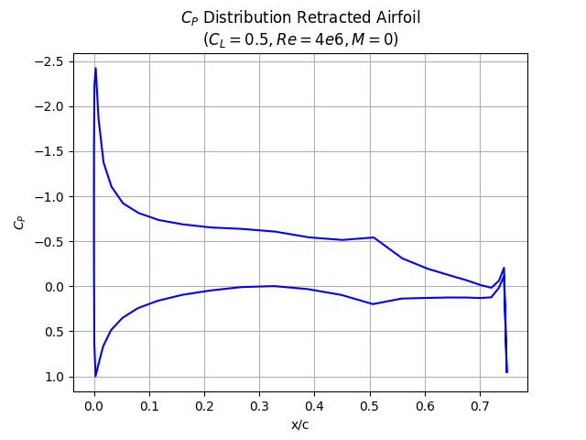
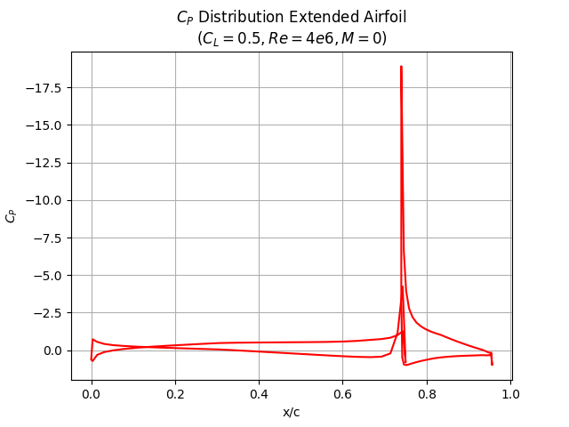
The plots above show the effect an extended flap has on the pressure distribution of an airfoil. In line with the previous lift polar, extending the flap reduces the required angle of attack for the same lift coefficient as is evident by the significantly smaller suction peak on the main airfoil. This reduces the adverse pressure gradient on the boundary layer and helps keep the flow attached.

Three parameters commonly used to refer to the design of a trailing edge flap are:
- flap gap
- flap overlap
- flap angle.

- Using the airfoil geometry that you used before, do the following:
- Add a modification of 5 degrees on the flap angle. In the first box add a figure comparing the new pressure distributions against the old one. Compare the variation of lift coefficient with respect to the expected $2πδ_{flap}⋅{c_{flap}}/{c_{ref}}$ and comment on observed effects in the box below.
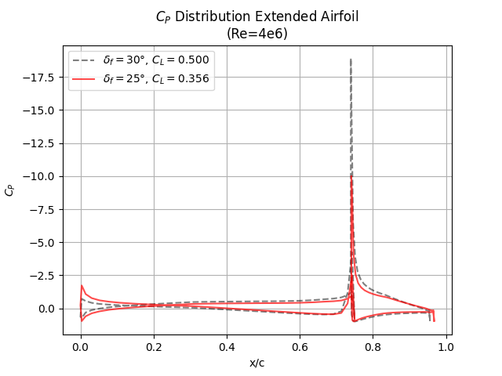

- Add a modification of 2% on the flap gap. Plot the new pressure distribution against the old one in the first box. Comment on the changes found in the second box.
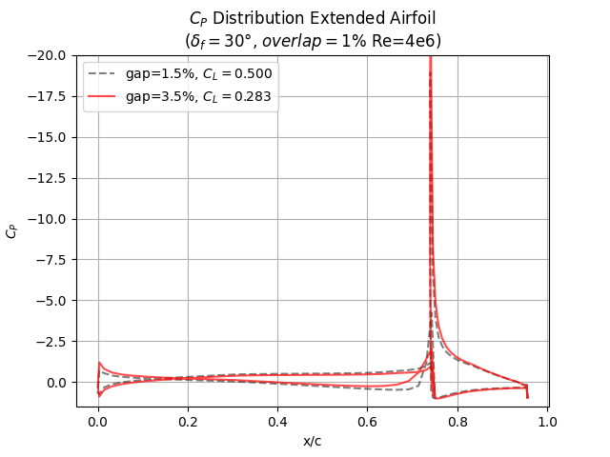

- Add a modification of 2% on the flap overlap. Plot the new pressure distribution against the old one on the first box. Comment on the changes found in the second box.
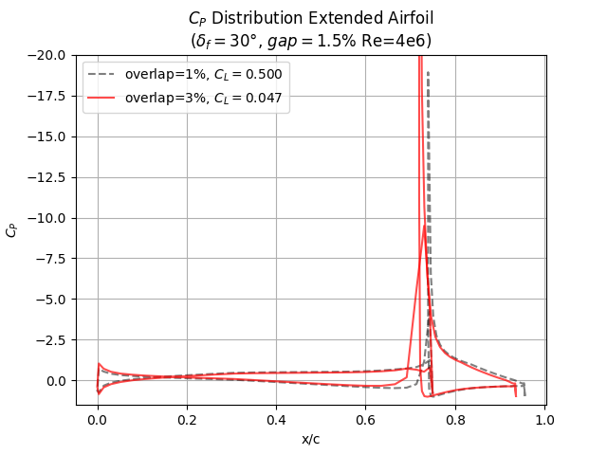

Task 3 – Wake-bursting effect
The so called ‘Wake-bursting’ effect can drastically affect the performance of a high-lift system.
- Describe in your own words how wake bursting occurs and discuss its influence on the drag and lift of the wing with high-lift system deployed.

- Add a hand-drawing, demonstrating the phenomenon and describe Gartshore’s condition for wake bursting.

=== End of Assignment ===

